Master’s Research - Spark Documentation

Apache Spark (Spark) was originally designed to be used with the scala API. However Spark also has APIs for other languages, specifically java, python, and R. In my master’s research I am using the python API, called pyspark, because I am very familiar with python and pyspark has a great deal of support from the open source community.

The purpose of this document is to provide guidance on potential problems that may arise in setting up and configuring Spark. I assume here that you have Spark 1.6.1 and its dependencies installed and will be using pyspark.

Some Basic Terminology
- SparkContext - main entry point for Spark functionality. A SparkContext represents the connection to a Spark cluster.

- RDD (Resilient Distributed Dataset) - a fault tolerance collection of elements that can be operated on in parallel; can be created via a SparkContext, typically a variable named sc.
Examples
sc.parallelize([1,"ABC", (3,4)]).count() creates a RDD from an array
sc.textFile("data.txt") creates an RDD from a text file

- Log4j (not to be confused with Py4J) - what Spark uses for logging, can be configured by editing the log4j.properties file which can be created from log4j.properties.template in the /conf directory
To quiet the Log4j logger so it only displays messages when there is an error, in the log4j.properties file change log4j.rootCategory=INFO, console to log4j.rootCategory=ERROR, console.

- Py4J - allows python programs to access objects in the Java Virtual Machine (JVM)
Since Java is in charge of distributing jobs to workers and we are using the python API for Spark, we need a way for the two languages to communicate.

Standalone Mode
In real-world scenarios, we are interested in harnessing the computing power of multiple machines to do analyses. So we create a cluster and this cluster needs a manager. I decided that Spark should be deployed as a standalone cluster because this avoids the need for a third party cluster manger such as Hadoop NextGen (YARN), Amazon EC2, or Apache Mesos. Spark can run without a cluster manager, but when we do this we are not making the best use of Spark. In standalone mode, even if we have just one machine we can create a pseudo-distributed system with a driver (master) and workers (slaves). They can be started as follows:

1)Navigate to the directory of the shell scripts
cd /<location of spark instance>/sbin
E.g. cd /usr/local/spark-1.6.1/sbin
2) Start master:
./start-master.sh
3) Start worker:
./start-slave.sh <master-spark-URL>
E.g. ./start-slave.sh 10.160.5.48:7077
4) Start history node:
./start-history-server.sh

Steps 2-4 in 1 go
./restart-spark.sh
There are similar scripts in the sbin directory to stop the cluster. The following diagram provides a visual of the relationships between the aforementioned.
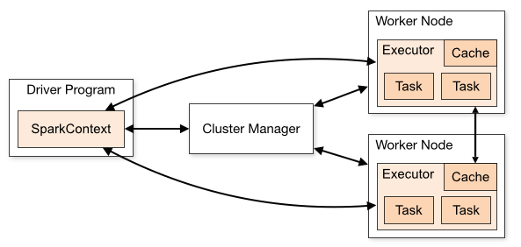

Ways to Submit Jobs/Applications
- The Interactive Shell
The interactive shell is for testing. There a spark context has already been created and configured for us. To exit the shell use Ctrl+D.

To start the shell navigate to the location of your Spark instance. Then type:
./bin/pyspark

You can avoid all this typing be creating an alias. All you would have to type as in the below image is:
pyspark.
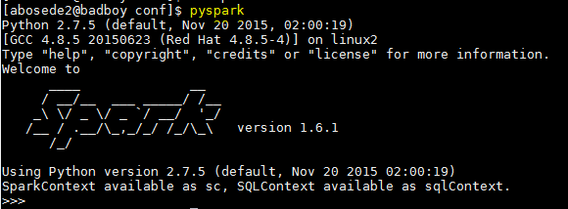

- spark-submit script
For programs in which SparkContext is defined use:
spark-submit <location of spark instance>/examples/src/main/python/<program name>.py <arguments to be passed into program>

Example using pi.py
spark-submit /usr/local/spark-1.6.1/examples/src/main/python/pi.py 10

Make sure to add sc.stop() to your python program, since only one spark context can be in use at any moment.

- Interfacing via Juptyer Notebook
A notebook is useful in sharing Spark applications and visualizing their results. I have chosen the Jupyter notebook because of its predecessor IPython and my comfort with IPython.

We allow Jupyter to import the SparkContext from pyspark by adding the following lines to our bashrc file.
export SPARK_HOME="<location of spark instance>"
export PYTHONPATH=$SPARK_HOME/python/:$PYTHONPATH

We should now get no errors when we type:
from pyspark import SparkContext

Make sure to add sc.stop() to your notebook, since only one spark context can be in use at any moment.

Monitoring
We can look at two different UIs to monitor jobs or applications. One is at the 4040 port and the other is at 8080.
The UI at the 4040 port is temporary and is only up when a spark context exists. Additional jobs will bind to successive ports (i.e. 4041, 4042, etc).

The UI at the 8080 port is for the cluster. Therefore it not only shows the status of the master, workers, and every job submitted, but also allows information to persist after the SparkContext has been stopped. However, each time the cluster is stopped existing information disappears from 8080 UI.

- Specifying the Master
When monitoring an application, it is very important to specify the master for the job or be aware of what the default master is. For instance if the default master is local, but the 8080 UI is for a master that is not local, you will not see your job on the 8080 UI if you did not specify the master URL for the UI.

Examples (we specify the master in the highlighted, 16 is the number of threads)
1) For spark-submit
spark-submit --master local[16] /usr/local/spark-1.6.1/examples/src/main/python/pi.py 10
spark-submit --master spark://10.160.5.48:7077 /usr/local/spark-1.6.1/examples/src/main/python/pi.py 10

2) For the shell
pyspark --master local[16]
pyspark --master spark://10.160.5.48:7077

3) For Jupyter notebook
from pyspark import SparkConf
sconf = SparkConf().setMaster("local")
sconf = SparkConf().setMaster("spark://10.160.5.48:7077")

We can set the default master in the configuration file, spark-defaults.conf, which can be created from spark-defaults.conf.template. For example we can add:
spark.master spark://10.160.5.48:7077

- Enabling Event Logging
Another important aspect of using the 8080 UI is enabling the logs. For example, we can add the below to spark-defaults.conf:
spark.eventLog.enabled true
spark.eventLog.dir file:///usr/local/spark-1.6.1/logs
If this is done as root, make sure that permissions are set such that all non-root users can still submit jobs.

By enabling event logging, we avoid getting the bellow message in the 8080 UI.
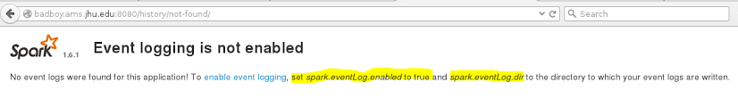

Add info about 18080 historical server port?
Packages
Packages are available to provide functionality not built into Spark. They are hosted at spark-packages.org. This website is similar to R’s CRAN.

- spark-csv
I have found the spark-csv package to be a useful addition which allows for CSV files can be read as DataFrame for use in SparkSQL. Spark-csv parses data as well as infers schema. To include version: 1.4.0-s_2.11 of this package in your Spark applications type:
pyspark --packages com.databricks:spark-csv_2.11:1.4.0
spark-submit --packages com.databricks:spark-csv_2.11:1.4.0

To add this package to your default application configurations either:
1) add the line below to spark-defaults.conf
spark.jars.packages com.databricks:spark-csv_2.11:1.3.0

OR

2) add the line below to your bashrc file
export PACKAGES="com.databricks:spark-csv_2.11:1.4.0"
export PYSPARK_SUBMIT_ARGS="--packages $PACKAGES pyspark-shell"

For more details on any of these topics and Spark in general, go to http://spark.apache.org/docs/latest/.

/home/dnaiman1/findata
OrderBookJun16.1.txt
TradesJun16.1.txt
http://www.rittmanmead.com/blog/2015/05/loading-updating-and-deleting-from-hbase-tables-using-hiveql-and-python/
http://hortonworks.com/blog/four-step-strategy-incremental-updates-hive/
java.lang.IllegalArgumentException: Timestamp format must be yyyy-mm-dd hh:mm:ss[.fffffffff]
at java.sql.Timestamp.valueOf(Unknown Source)
at com.databricks.spark.csv.util.TypeCast$.castTo(TypeCast.scala:62)

Check memory free
[abosede2@badboy sbin]$ free -m
total used free shared buff/cache available
Mem: 128727 5423 105426 799 17877 121933
Swap: 122059 5498 116561
Check number of cores
[abosede2@badboy sbin]$ nproc
32
[abosede2@badboy sbin]$ lscpu
Architecture: x86_64
CPU op-mode(s): 32-bit, 64-bit
Byte Order: Little Endian
CPU(s): 32
On-line CPU(s) list: 0-31
Thread(s) per core: 2
Core(s) per socket: 8
Socket(s): 2
NUMA node(s): 2
Vendor ID: GenuineIntel
CPU family: 6
Model: 45
Model name: Intel(R) Xeon(R) CPU E5-2660 0 @ 2.20GHz
Stepping: 7
CPU MHz: 1212.406
BogoMIPS: 4403.59
Virtualization: VT-x
L1d cache: 32K
L1i cache: 32K
L2 cache: 256K
L3 cache: 20480K
NUMA node0 CPU(s): 0,2,4,6,8,10,12,14,16,18,20,22,24,26,28,30
NUMA node1 CPU(s): 1,3,5,7,9,11,13,15,17,19,21,23,25,27,29,31

[abosede2@badboy ~]$ df /
Filesystem 1K-blocks Used Available Use% Mounted on
/dev/sda1 153242516 21377384 131865132 14% /
[abosede2@badboy ~]$ df
Filesystem 1K-blocks Used Available Use% Mounted on
/dev/sda1 153242516 21377384 131865132 14% /
devtmpfs 65893940 0 65893940 0% /dev
tmpfs 65908480 12 65908468 1% /dev/shm
tmpfs 65908480 4154808 61753672 7% /run
tmpfs 65908480 0 65908480 0% /sys/fs/cgroup
/dev/sdd2 1878229060 77848 1782719184 1% /new_data
/dev/mapper/var--vol-var 24404336 2234704 22169632 10% /var
/dev/mapper/backup--vol-backup 1854561532 1338795080 515766452 73% /backup
/dev/mapper/home--vol-home00 1854561532 1376362708 478198824 75% /home
tmpfs 13181696 0 13181696 0% /run/user/831735269
tmpfs 13181696 52 13181644 1% /run/user/831642939
tmpfs 13181696 32 13181664 1% /run/user/831735260
[abosede2@badboy ~]$ cd /new_data/
[abosede2@badboy new_data]$ ls
lost+found

Ways to submit app - should add driver/executor mem driver cores to spark conf file
spark-submit --master local[16] --driver-cores 32 --driver-memory 16g --executor-memory 16g trade_data_count.py
spark-submit --master spark://10.160.5.48:7077 --driver-cores 32 --driver-memory 16g --executor-memory 16g trade_data_count.py

Caching issue
Partial action

http://badboy.ams.jhu.edu:8080/app/?appId=app-20161016122646-0026

/home/scala/spark-1.6.1$sudo sbt/sbt -Phive assembly
[dnaiman1@badboy spark-1.6.1]$ cd project/
[dnaiman1@badboy project]$ ls
build.properties MimaBuild.scala MimaExcludes.scala plugins.sbt project SparkBuild.scala
[dnaiman1@badboy project]$ cd ..
[dnaiman1@badboy spark-1.6.1]$ ls build
apache-maven-3.3.3 mvn sbt sbt-launch-lib.bash scala-2.10.5 zinc-0.3.5.3
[dnaiman1@badboy spark-1.6.1]$ sudo ./build/sbt -Phive assembly

Count rows in file
wc -l trades_pivot_vol_2016-10-19.txt

[abosede2@badboy ~]$ pyspark
Presence of build for both scala versions(SCALA 2.10 and SCALA 2.11) detected.
Either clean one of them or, export SPARK_SCALA_VERSION=2.11 in spark-env.sh.

/usr/local/spark-1.6.1/build/scala-2.10.5/
/usr/lib/scala-2.11.8/

Conclusion Rustam did not use sbt script to build spark, but maven.
Spark comes with scala 10. We build for this version since we used sbt
Rustam built spark for scala 11

The jars for the packages stored in: /home/abosede2/.ivy2/jars
:: loading settings :: url = jar:file:/usr/local/spark-1.6.1/assembly/target/scala-2.11/spark-assembly-1.6.1-hadoop2.2.0.jar!/org/apache/ivy/core/settings/ivysettings.xml

VS
The jars for the packages stored in: /home/abosede2/.ivy2/jars
:: loading settings :: url = jar:file:/usr/local/spark-1.6.1/assembly/target/scala-2.10/spark-assembly-1.6.1-hadoop2.2.0.jar!/org/apache/ivy/core/settings/ivysettings.xml

